Chapter 12: Motion and Time
Que1: MCQ
- 1
- 1
- 2
- 4
- 2
- 2
Que2: Fill in the blanks
- Non Uniform motion
- Distance-time graph
- Speed
- Galileo Galilei
- Time period
Que3. True or False
- True
- False
- True
- True
- True
- False

Que 4. Very short answer type question
- What is the change in position of a body with respect to time called?
Ans: The change in position of a body with respect to time is called Motion.
- What is another name for sand clock?
Ans: The another name for sand clock is hour glass.
- What is the small metallic ball of simple pendulum called?
Ans: The small metallic ball of simple pendulum is called bob.
- What is the SI unit of time?
Ans: The SI unit of time is second
- Which device is used to measure distance in a car?
Ans: Odometer device is used to measure distance in a car.
Que5. Short answer type question
- What is an Oscillation?
Ans: The to and fro movement of a swinging pendulum is called oscillation.
- Define time period of a pendulum.
Ans: The time taken for the pendulum to complete one oscillation is called its time period.
- What are stopwatches used for?
Ans: Stopwatches are used for measuring short intervals of time.
- What does a distance time graph indicates?
Ans: A distance –time graph shows how distance travelled by a moving object changes with time. The slope of the graph shows speed of the object.
- Define non-uniform motion.
Ans: If a body covers unequal distance in equal intervals of time then it is said to be in non-uniform motion.
Que 6. Long answer type question
- What do you mean by slow and fast motion?
Ans:
- The distance of an object covers in a given interval of time enables us to know whether an object is moving fast or slow.
- An object is said to be in ‘fast motion’ if it covers more distance in small interval of time.
- An object is said to be in ‘slow motion’ if it covers short distance in longer interval of time.
- For example: An ant moving on a ground is said to be in slow motion while an aeroplane flying in the sky is said to be in fast motion.

- Distinguish between uniform and non-uniform motion.
Ans:
 | Uniform motion |  | Non-uniform motion
1. | If a body covers equal distance in equal intervals of time then it is said to be in uniform motion. | 1. | If a body covers unequal distance in equal intervals of time then it is said to be in non-uniform motion.
2. | The body in uniform speed has a constant speed | 2. | The body in non- uniform speed does not has a constant speed
3. | The distance –time graph obtained is a straight line | 3. | The distance –time graph obtained is not a straight line

- Give a brief account of different types of clocks used in early times.
Ans:
- Sundial: A sundial worked on the principle that the position and the length of the shadow cast by an object changes with position of the sun in the sky
- Sand clock: The sand clock works on the principle that a definite amount of sand takes a constant time to fall from upper chamber to the lower chamber.
This constant time was taken as the unit of measurement of time which was called an hour. Therefore, sand clock is also called an hour glass.
- Pendulum clock: Pendulum clock was also used to measure time. Galileo Galilei discovered that a swinging pendulum takes a fixed time to complete one oscillation .The to and fro movement of a swinging pendulum is called oscillation.

- What points should be kept in mind while plotting a graph?
Ans: Some points should be kept in mind while plotting a graph
- Choose a scale so as to utilize the maximum part of the graph paper.
- Keep in mind the difference between the highest and the lowest values of each quantity.
- Keep in mind the intermediate values of each quantity, so that the scale chosen is convenient to mark the values on the graph.
- Mark the values for time and distance on the respective axes according to the scale chosen.
- Join all the marked points with pencil extending the line to 0 second and 0 distance i.e point O

- The distance covered by a body after every 3 seconds is given in the table.
Time (in sec) | 3 | 6 | 9 | 12
Distance covered (in m) | 4 | 8 | 12 | 16
Plot the distance time graph and find the speed of the body.

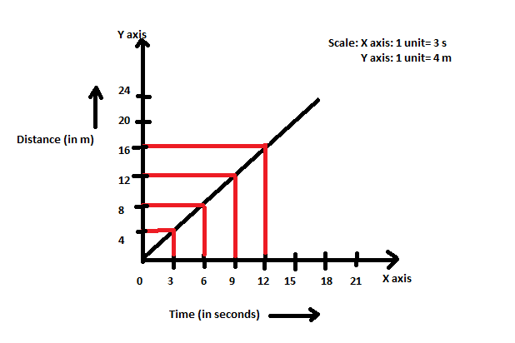
Here, Distance= 4 m
Time = 3 s
Speed= Distance/Time
S= 4/3
S= 1.33 m/s

Since, we obtained a straight line on graph. It means that it is a uniform motion, which has a constant speed i.e 1.33 m/s.

Que 7. Solve the following numerical
- A car travels from Delhi to Agra in 3 hours. If the distance between the two cities is 180km, what is the average speed of the car?
Sol:
Distance= 180km
Time Taken= 3 hrs
Speed= Distance/Time
S=180km/3 h
S=60 km/h
Thus the average speed of the car is 60 km/h

- A boy covers a total distance of 350 km in his car with an average speed of 50km/h. How much time does he take?
Sol:
Distance= 350 km
Speed= 50 km/h
Speed= Distance/Time
Or
Time = Distance/ Speed
T=350/50
T=7 hrs
Thus the time taken is 7 h.

- A girl cycles from her house to school at a speed of 18 km/h and reaches there in 20 minutes. Find the distance of the school from the house.
Sol:
Speed = 18 km/h
Time= 20 minutes i.e (20 /60 hrs) (converting min into hrs)
=1/3 hrs
Distance= Speed × Time
D = 18 × 1/3
D= 6 km
Thus the distance travelled is 6 km

- Raghav walked a distance of 270 metres from his house to the market in 3 minutes. What is his speed of walking?
Sol:
Distance =270 m
Time= 3 minutes i.e( 3×60 sec) ( converting min into sec)
=180 s
Speed= Distance/Time
S= 270/180
S= 1.5 m/s
Thus the speed is 1.5 m/s

- A man was driving his car at the speed of 60 km/h. How far will he travel in 5 hours if he moves with the same speed?
Sol:

Speed= 60 km/h
Time= 5 h
Distance= Speed × Time
D = 60 × 5
D= 300 km
Thus the distance travelled is 300 km

